|  |  |
| --- | --- |
| To: | Cabinet |
| Date: | 11 December 2024 |
| Report of: | **Head of Planning and Regulatory Service** |
| Title of Report: | **Authority Monitoring Report and Infrastructure Funding Statement 2023/24** |

|  |  |  |
| --- | --- | --- |
| Summary and recommendations | | |
| Purpose of report: | | To approve the Authority Monitoring Report and Infrastructure Funding Statement for publication. |
| Key decision: | | No |
| Cabinet Member: | | Councillor Louise Upton, Cabinet Member for Planning |
| Corporate Priority: | | Strong, fair economy  Good, affordable housing  Thriving communities  Zero carbon Oxford  A well-run council |
| Policy Framework: | | The Authority Monitoring Report is a statutory requirement, providing information as to the extent to which the policies set out in the Oxford Local Plan are being achieved and on the implementation of the Local Development Scheme. The scope of those policies is wide and encompasses all of the Council’s corporate priorities.  The Infrastructure Funding Statement is a factual report and statutory requirement which summarises the amount of developer contributions (Community Infrastructure Levy (CIL) and Section 106) obtained, allocated and spent by the authority in the previous financial year (April 2023– March 2024). |
| Recommendation(s): That Cabinet resolves to: | | |
| 1. | Approve the Authority Monitoring Report and Infrastructure Funding Statement 2023/24 for publication. | |
| 2. | Authorise the Head of Planning and Regulatory Services to make any necessary minor corrections not materially affecting the document prior to publication. | |

|  |  |
| --- | --- |
| Appendices | |
| Appendix 1 | Authority Monitoring Report 2023/24 |
| Appendix 2  Appendix 3  Appendix 4 | Infrastructure Funding Statement 2023/24  Risk Assessment  Equalities Impact Assessment |

# Introduction and background

1. Section 35 of the Planning and Compulsory Purchase Act 2004 requires local planning authorities to publish monitoring reports at least yearly, in the interests of transparency.
2. The Authority Monitoring Report (AMR) 2023/4 assesses the effectiveness of planning policies contained within the Oxford Local Plan (OLP) 2036 as well as the implementation of the Oxford Local Development Scheme 2023-2028, the Council’s Statement of Community Involvement in Planning and the Duty to Cooperate. The AMR covers the period 1st April 2023 to 31st March 2024 and is a factual document.
3. The AMR is structured as follows: a status report on the production of development plan documents, followed by the monitoring of the Oxford Local Plan 2036 policies. Policy monitoring has been arranged around the three overarching objectives set out in paragraph 8 of the National Planning Policy Framework (NPPF) 2023[1]:

* Economic objectives to build a strong, responsive and competitive economy - the economy, retail, community and infrastructure;
* Social objectives to support building strong, vibrant and healthy communities – housing, health and community benefits; and
* Environmental objectives to project and enhance our natural, built and historic environment – design and heritage, protecting our green and blue spaces and making wise use of our natural resources to secure a good quality local environment.

1. The Infrastructure Funding Statement (IFS) is a reporting requirement introduced in September 2019 as an amendment to the Community Infrastructure Levy 2010, with the objective of increasing transparency around how developer contributions are spent on infrastructure. As set out in Appendix 2, the contents of the IFS are divided into three key sections for the previous financial year:
2. Information on Community Infrastructure Levy (CIL) contributions;
3. Information on Section 106 contributions (made under section 106 of the Town and Country Planning Act 1990);
4. Items of infrastructure that CIL is to be spent on in the next five years (CIL is allocated to the Council’s Capital Programme as part of the Budget setting process).

# Key AMR findings: Building a strong, responsive and competitive economy

# *Employment land*

1. Oxford’s highly constrained nature means that competition for different land uses is fierce. As such Policy E1: Employment Sites sets out how employment sites are categorised in order of importance and thus afforded different levels of protection. Category 1 & 2 employment sites are key in providing employment space for the city, whereas Category 3 sites and B8 sites provide more potential to be released from employment uses to ensure the best and most efficient use of land.

* Two permissions were granted resulting in the net loss of Category 2 employment floorspace (none involving Cat. 1): First floor, 27-28 St Clement’s Street (-170sqm); and 24 Unit D Peterely Road (-992sqm);
* Total loss of Category 3 employment floorspace (permissions): 2,212.95m2;
* Total gain of employment floorspace (permissions): 84,602.00 (compared to 8,828m2 in the previous monitoring year;
* Applications for changes of use from office to residential which are subject to notification to the council: 3 applications granted (all involving loss of Category 3 sites and overlapping with that total loss figure above).

# *Growth of Oxford’s universities*

1. The City Council is committed to supporting the sustainable growth of the two universities within the parameters of competing demands for land. The universities are encouraged to focus growth on their own sites by making the best use of their current landholdings and the redevelopment and intensification of their assets where appropriate. Policy E2: Teaching and Research states that new or additional academic floorspace will only be granted if it is demonstrated that additional student accommodation is not required or is provided as set out in Policy H9: Linking the delivery of new/redeveloped and refurbished university academic facilities to the delivery of university provided residential accommodation.
2. The University of Oxford had 26,945 students attending the University and its colleges as of 1st December 2023; of these 11,541 were excluded from accommodation needs as they were not on full time taught courses, leaving 15,404 full-time students with accommodation needs. On 1st December there were 14,603 accommodation places provided, leaving a total of 801 students the policy applies to living outside of university accommodation which is within the threshold set out in policy H9 for the University of Oxford.
3. Oxford Brookes University (OBU) states there were 19,586 students attending the university as of 1st December 2023 (compared to 16,050 the year before). Of these 11,009 were excluded from accommodation needs, leaving 8,577 full-time Oxford Brookes students requiring accommodation. On 1st December 2023 there were 4,857 student places provided leaving 3,720 students the policy applies to without a place in university provided accommodation. This is below the threshold set out in policy H9 for Oxford Brookes, although this figure does represent an increase in the number of students outside of university provided accommodation when compared to previous monitoring periods (2020/21 – 2,873; 2021/22 - 2,633; 2022/23 - 2,908).

*Summary of university monitoring data:*

* Approved additional academic and administrative floorspace: 77.6m2;
* Number of University of Oxford students living outside of provided accommodation: 801 – within policy H9 threshold;
* Number of Oxford Brookes students living outside of provided accommodation: 3,720 – within policy H9 threshold.

# *Ensuring the vitality of our centres*

1. Oxford provides a wide range of services and facilities to both residents and visitors alike, and policies have been drafted in the OLP 2036 to maintain and enhance this vibrancy and vitality. Policy V1 aims to protect the town, district and local centres, whilst Policies V2-V4 provide the framework as to what mix of uses would be acceptable. Because the use classes referred to in policies V1-V4 were superseded by the introduction of the new Use Class E, the AMR instead reports on the current percentage share of Use Class E. The proportion of Use Class E (used as a proxy for the threshold for Use Class A set out in the policies) is above the policy thresholds for Class A for Cowley, Headington, Summertown and primary city centre shopping frontage (meaning that change of use involving a loss of Use Class E would be acceptable in principle). The proportion of Class A uses is 80% in East Oxford (Cowley Road), which is below the 85% threshold. In the city centre secondary frontage the proportion is 75%, below the 85% threshold.

***Sustainable tourism and cultural venues, community facilities and infrastructure***

1. Tourism is an important and substantial element of Oxford’s economy. The provision of short stay accommodation allows more options for tourists to stay over in the city and thus bring more money into the local economy. Policy V5: Sustainable Tourism seeks to locate new tourist accommodation in accessible locations to reduce dependency on the private car, and in addition the policy does not permit new accommodation if it would result in the loss of residential dwellings. New tourist attractions in the city must be easily accessible by active travel or public transport and be well related to existing tourist and leisure facilities. Policies V6 and V7 seek to protect cultural, social and community facilities.

* Planning permission granted for additional hotel bedrooms: one permission for an increase of 36 rooms at Linton Lodge Hotel.
* 2 applications involving loss of rooms- 12 rooms altogether, both applications from C1 to HMO.

# Key AMR findings: Building strong, vibrant and healthy communities

# *Housing*

1. In this monitoring year 365 (net) dwellings were completed in Oxford of which 61 were affordable dwellings. This includes the equivalent numbers calculated through the application of ratios for communal accommodation (student completions and other communal accommodation). Whilst the number of completions in the 2023/24 monitoring year has fallen below the Local Plan’s annual requirement, the cumulative number of dwellings completed in the 7 years since the start of the Local Plan period (2016/17 to 2023/24) is 4,145 dwellings (net). The housing trajectory had projected that by 2023/20243, 4,076 dwellings (net) would have been provided (Figure 1). Figure 2 below shows the cumulative projection is just under the target to meet the minimum of 10,884 dwellings to 2036 as set out in policy H1, and officers are working to maximise opportunities to deliver housing to meet the target.

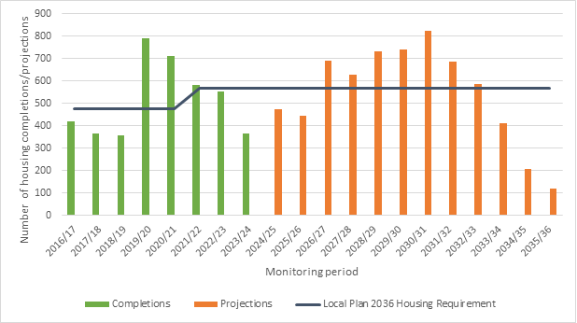  
***Figure 1:*** *Local Plan 2036 Completions and Projections*

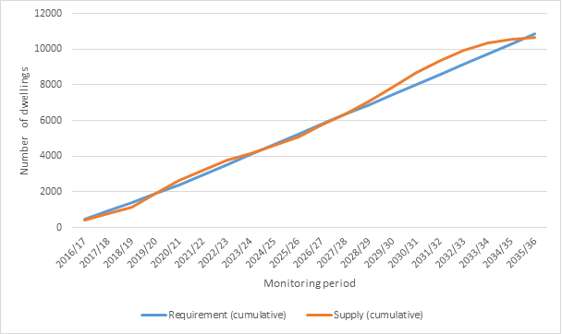  
***Figure 2****: Cumulative Requirement and Cumulative Supply*

1. The breakdown of the 61 affordable dwellings completed during the monitoring year is as follows: 11 social rent at Barton Park Phase 3; 7 shared ownership at Littlemore Park; 4 social rent and 6 intermediate rent at Warren Crescent; 3 social rent and 2 shared ownership Frideswide Farm; 15 social rent, 3 intermediate rent and 8 shared ownership at Lucy Faithful House and 8 Speedwell Street; 1 social rent at Foxwell Drive, 1 social rent at Roken House, Lake Street . Since the start of the Local Plan period there have been a total of 998 affordable homes built (Figure 3). 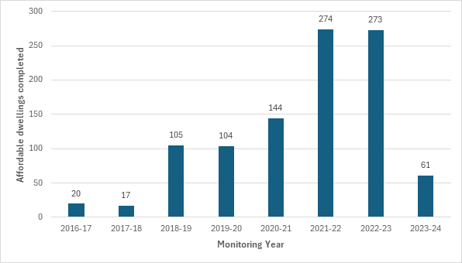

**Figure 3:** Net affordable dwellings completed 2016/17 - 2022/23

The Council is committed to delivering more affordable housing in Oxford and has been identifying land in its ownership capable of delivering affordable homes and bringing this forward wherever possible. Of the 61 affordable dwellings completed in 2022/23, 49 were delivered on City Council Land.

*In summary:*

* Net dwellings completed in 2023/24: 365 of which 61 were affordable:
* Affordable units delivered on council land in 2023/24: 49,
* Net C3 dwellings permitted in 2023/24:178; of which were affordable: 90.

# *Provision of new student accommodation*

1. There were 5 planning permissions for student accommodation, all of which were compliant with the location criteria set out in Policy H2.

* Applications for new student accommodation: 5
* Number of new student rooms with permission: 221.

***Housing land supply***

1. The Plan’s annual housing requirement is used to calculate the 5-year housing land supply as set out in the NPPF. The Council has identified a deliverable supply of 2,955 homes which includes the forecast supply from large sites, including those which have been allocated in the Local Plan and outstanding permissions from small sites (commitments) plus a windfall allowance. This gives a housing land supply of 5.49 years which is very similar to the figure reported in last year’s AMR.
2. Whilst Figure 2 above indicates that the forecast supply drops below the requirement over the next five-year period, over the longer term the forecast supply is always above the requirement, with the gap between the two increasing from year 6 (28/29). Work on the Local Plan 2040 has provided further updates on the anticipated delivery of some of the large trajectory sites, alongside a further round of landowner engagement to inform our Housing and Economic Land Availability Assessment (HELAA).

* Housing land supply: 5.49 years.

# Key AMR findings: Oxford’s Historic Environment

1. There are three buildings are on English Heritage’s at-risk register, with Minchery Farmhouse having been added since the previous monitoring year.

**Key IFS Headlines**

1. The IFS reports on the developer contributions received, allocated and spent for 2023-24.
2. £5,674,069.08 of CIL was collected in 2023-24 and £1,710,565 of CIL was spent towards infrastructure projects. £4,807,228.51 of CIL was set out in demand notices in the year for collection.
3. £1,710,564.75 of CIL was spent on strategic infrastructure; £112,941.42 was passed to Parish Councils; £1,221,369.95 was received in 23/24 to be allocated or spent towards Neighbourhood forums and Neighbourhood CIL, and £145,091.37 was spent by Neighbourhood Forums. As per the CIL regulations, £140,343.01 was spent on administration fees.
4. In 2023-24, £193,670.15 was received in Section 106 agreements and £1,829.62 was spent towards infrastructure projects. A further £655,484.00 of S106 agreements were entered into in the year;
5. From the total of £14,137,534.84 received under Section 106 planning obligations but not spent in the year 23-24, contributions are allocated to be spent on primarily affordable housing (£12,294,478.39); followed by open space/green infrastructure (£1,295,193.79); Community facilities (£237,000.00) Highways/transport and travel (£227,029.75); and Other/Economic development uses (£39,880.00).
6. 384 units of Affordable housing are to be provided from Section 106 agreements entered into in 2023-24.

# Carbon and Environmental Considerations

1. There are no specific carbon and environmental implications arising from this report. Policies in the Local Plan are seeking to optimise opportunities for carbon reduction. This statutory framework brings us closer to our commitment to becoming a Zero Carbon Council by 2030 or earlier and Zero Carbon Oxford by 2040 or earlier.

**Financial implications**

1. There are no financial implications arising from these reports. The IFS simply reports on the collection and spending of monies through the Community Infrastructure Levy (CIL) and S106 developer contributions.

**Legal issues**

1. The publication and content requirements of the AMR (Appendix 1) are set out in section 35 of the Planning and Compulsory Purchase Act 2004 and regulation 34 of the Town and Country Planning (Local Planning) (England) Regulations 2012.
2. The requirements for the publication and content of the IFS (Appendix 2) are set out in Regulation 121A and Schedule 2 of the Community Infrastructure Levy Regulations 2010.

**Level of risk**

1. A risk assessment has been undertaken and the risk register is attached (Appendix 3).

**Equalities impact**

1. Please refer to Equalities Impact Report (Appendix 4).

|  |  |
| --- | --- |
| **Report author** | Sarah Harrison, Lorraine Freeman |
| Job title | Planning Policy Team Leader and CIL, Data Analysis and Reporting Team Leader |
| Service area or department | Planning Policy, Planning Services |
| Telephone | 01865 529137/ 252509 |
| e-mail | [Sharrison@oxford.gov.uk](mailto:Sharrison@oxford.gov.uk) [lfreeman@oxford.gov.uk](mailto:lfreeman@oxford.gov.uk) |

|  |
| --- |
| Background Papers: None |

1. https://www.gov.uk/government/publications/national-planning-policy-framework--2